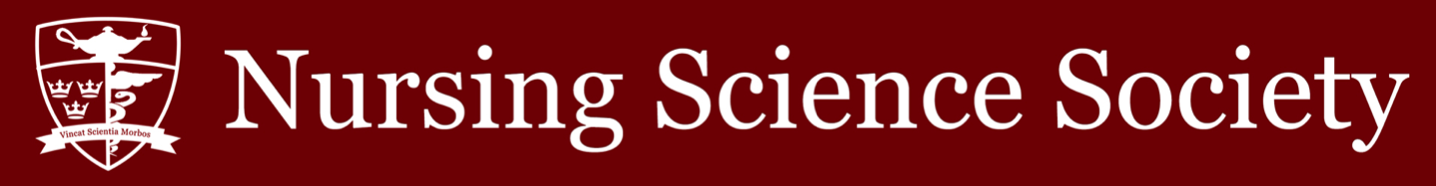

Date: September 22, 2021 Time: 7:00 pm

Minutes Taker (Position): Azra Jeraj (Vice President of Operations)
Purpose of Meeting: NSS Assembly Meeting

In Attendance:

✓ Nathaniel Gumapac (President)
✓ Emma Harris (Vice President,
University Affairs)
✓ Azra Jeraj (Vice President, Operations)
✓ Crystal Sau (Senator)
✓ Hikari Asaoka (Presidential Intern)
✓ Adelle Pagura (VPOPs, Intern)
✓ Anita Thevarajah (VPUAs, Intern)
☐ TBD (NSS Assembly Speaker)

✓ Herbert Song (Academic & Professional Development Commissioner)
☐ TBD (Social Issues Commissioner)
✓ Mila Jones (Health and Wellness Commissioner)
✓ Matthew Zhang (Events Commissioner)
✓ Katelyn Tigchelaar (Interprofessional
Commissioner)
✓ Jennifer Zhang (Director of Global Health)
☐ TBD (CNSA Official Delegate)
☐ TBD (CNSA Associate Delegate)
✓ Kerry Xu (International Student
Representative)
✓ Deepti Devgan (BIPOC Student
Advocate)
☐ Carleigh Higgins (Head Cape) - excused

✓ Julia Testani (Class of 2022 President)

✓ Nicole Gumapac (AST 2022 Class President)
☐ TBD (AST Class of 2023 President)
✓ Liam Murdock (Class of 2023 President)
✓ Dylan Rodgers (Class of 2024 President)
☐ TBD (Class of 2025 President)

Meeting Minutes

7:05 Meeting begins

7:06 Motion #1 to approve agenda for the meeting for September 22nd is passed

7:07 Motion #2 to approve meeting minutes from September 8th

7:08 President’s report: AMS update from president’s caucus meeting, wellness advisor, social media outreach, hiring

7:10 VPOPs report: NSS appreciation event update, health and wellness giveaways, summer highlight giveaway, NSS intern hiring update, NSS hiring information

7:14 VPUA’s report: NSS social media update, hiring updates, guest speakers for assembly, AMS assembly information

7:22 Senator’s report: fall term break task force update,

7:26 Welcome to our new intern hires: Presidential Intern Hikari Asaoka, VPOPs Intern Adelle Pagura, and VPUA Intern Anita Thevarajah.

7:26 Academics commissioner’s report: study buddies mentor updates, instagram posts surrounding midterms and APA formatting

7:28 Health and wellness commissioner's report: giveaway update, mental health week collaboration

7:29 Events commissioner's report: brainstorming and researching event ideas

7:30 IP commissioner’s report: card drive and engineering/nursing collaborative event
7:31 International student representative’s report: goal of raising student awareness about mental health, and providing workshops in collaboration with Wellness Advisor

7:32 Head cape’s report: NOC hiring is taking place, ideally done by October 22nd

7:33 Global health commissioner’s report: ‘Nursing Specialty Spotlight Instagram’ project, finding guest speakers to talk about global health

7:34 Year 2 Class President’s report: orders are taking place for scrub /stethoscope / BP cuff / lab coat

7:35 Year 3 Class President’s report: looking to plan event for year 3

7:36 Year 4 Class President’s report: blood drive for the term is almost booked up, will be ordering “Your Type” bars soon, headshots in October/November, yearbook committee, graduation merch with jcraftandco

7:40 AST Year 4 Class President’s report: working for Year 3 jackets, pinning ceremony funding / planning

7:42 New business: NSS ratifies new interns into their positions. NSS ratifies BIPOC Student Advocate

7:55 Question period

8:02 Motion to adjourn meeting passes.

