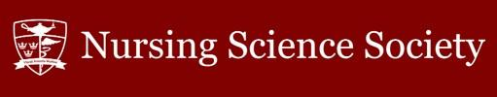

2022 NSS Fee Breakdown

Presented by: Maxwell Yuen, Vice President of Operations
Fiscal Year: January 2023 – December 2023
Completed on: January 10, 2023

Introduction

The 2022 NSS Fee Breakdown is a detailed explanation of funding allocation by the paying student. Breakdown and presentation of these values ensures financial transparency of all NSS expenses.

Preliminary Information

Number of students…………………………………………………………………………………………….551

Current NSS ancillary fee per student...………….………………………………………………..$61.75

Summary of Funds

Predicted revenue (‘income’)………………………………………………………………….…$72,371.64

Predicted budget (‘use’).…………………………………………………………………………..$32,930.52

Net residual (‘remaining’).……………………………………………………………………..$40,441.12

Predicted Revenue

Revenue is calculated based on nursing student fees through NSS fees, the Financial Stability fee, and the 2021 surplus. The Alma Mater Society (AMS) of Queen’s University directs the money to the NSS by depositing 90% of fees in Dec. 2021 the Winter 2022 term and 10% of fees in the summer of 2022 for the Fall 2022 term. Thus, 100% of student fees to the NSS are received by Fall 2022.

90% of Student Fees……………………………………………………………………………….$25,281.66

10% of Student Fees…………………………………………………………………………………$7,209.10

Financial Stability Fee………………………………………………………….………………………$1217.31

2021 Surplus…………………………………………………………………………….…………….$39,633.57

Total Revenue………………………………………………………………………………………….$72,371.64

Predicted Budget – Financial Breakdown

Please see ‘2022 NSS Student Fee Chart’ for a visual depiction of NSS student fee allocations.

Health Training and Workshops - $798.95
Health and Wellness Commissioner

Health and Wellness training workshops and wellness related events. Events and resources may include exam destressors, mental health training, OSCE workshops, and speaker series.

Professional Development - $798.95
Academics and Professional Development Commissioner

Academics and Professional Development Commissioner's portfolio is to provide workshops, skill building, networking opportunities for students to expand their professional skill set and discover career opportunities.

Study Buddies Program - $617.12
Academics and Professional Development Commissioner

Study Buddies is a program where upper year tutors are hired to hold open tutoring sessions in specific courses for nursing students. This program runs both terms and sessions are geared around the timing of midterm and final exams.

Words of Wisdom - $66.12
Events Commissioner

Words of Wisdom is a speaker series where NSS invites several speakers from various fields to share their Nursing experience and journey to students. This service provides career support for students as they navigate their studies.

NSS Assembly Meetings - $385.70
Executive Team

Open attendance and informative approaches to bi-weekly assemblies is promoted through space rentals, food, and appreciation to guest speakers. All students are welcome to attend and learn about positions and opportunities.

NSS Athletics - $551.00
Interprofessional Commissioner

An annual dodgeball tournament between the three schools in the Faculty of Health Sciences – Nursing, Medicine, and Rehabilitation. The event is by donation, and money raised goes to support a local charity in the Kingston community.

Class Councils - $2573.17 / 6 classes = $428.86 per council
Class Councils

Class councils run events to increase and strengthen rapport within the year and between different years. The fee allows for events, fundraisers, treats and more to be done to support the class and contribute to graduation fees.

CNSA Membership - $5510.00
CNSA Official and Associate Delegates

Membership with access to CNSA scholarships, grants, national and local conferences and opportunities for professional development and networking (1). Organization actively dedicated to positive promotion of nurses and the nursing profession.

Graduation Fee - $13,653.78
Class of 2022 (four-year and AST) Class Councils

For the pinning ceremony, a longstanding tradition for nursing students, which runs in conjunction with convocation. Pinning committee uses the funding for the venue, decorations, graduation gifts and tickets, alongside fundraising.

Health and Wellness Portfolio - $798.95
Health and Wellness Commissioner

To provide resources to help inform students about health and wellness in relation to nursing and provide opportunities to practice those skills. Events, such as Zumba and yoga, are run throughout the year alongside other initiatives.

Intern Project - $617.12
Interns

Allows for the NSS interns to develop or integrate a project, initiative or resource into the nursing community and highlight nursing students. Previous projects included a media project and redesigning the nursing student lounge.

Mentorship Program - $798.95
Events Commissioner

The mentorship program is under the Events Commissioner's profile and provides incoming students with an opportunity to be paired with an upper year student or “buddy” throughout the year for social, academic or personal support.

National Nursing Students’ Week - $308.56
CNSA Official and Associate Delegates

NNSW is an annual, weeklong event to showcase the contributions of nursing students to their practice settings and celebrate their accomplishments in nursing. Throughout the week, giveaways, prizes, and events are hosted for students.

NSS Appreciation - $551.00
Executive Team

Allows for a token of appreciation to be awarded to NSS assembly members and thank them for their contributions to the society during their term.

NSS Office - $187.34
Executive Team & Interns

Maintenance and upkeep of the NSS Lounge and office, including coffee and tea for students, replacement of damaged items, snacks, utensils and school supplies for the use of students.

NSS Website - $308.56
Vice President, Operations

The NSS website is an interface with details about the NSS assembly, assembly minutes and agendas, calendar, and photo gallery. Students can find important nursing-related information, tips and tricks, and ways to get involved.

General Bursary - $881.60
Executive Team & Head Capes

NSS financial aid available for nursing students who apply in order to participate in nursing related events or Orientation week. The NSS General Bursary is available to all undergraduate nursing students.

Orientation Week - $1,322.40
Head Capes

Orientation Week is a week for students to familiarize themselves with nursing and Queen’s University. During the week, the NSS hosts a meet-and-greet and lunch on 'Beach Day' to orient incoming students to services and opportunities.

Student Initiative Fund - $1,228.73
Executive Team

The NSS Student Initiative Fund is funding for nursing students who may need financial aid or who submit a proposal for an initiative that benefits nursing students. This fund supports student projects, ideas, events, or collaborations.

Textbook Library – $837.52
Executive Team & Interns

Located in the nursing student lounge, the library supplies undergraduate nursing textbooks for use throughout the semester. Textbooks are regularly updated so students have access to educational resources for their courses.

Banking Charges - $10.00
Vice President, Operations

The NSS manages its operating budget through electronic banking software and requires small annual operating fees to maintain an account in good standing.

AMS Annual Voting Fee - $125.00
Vice President, University Affairs

The NSS uses the AMS online voting system for all elections and pays an annual service fee to continue using this interface.

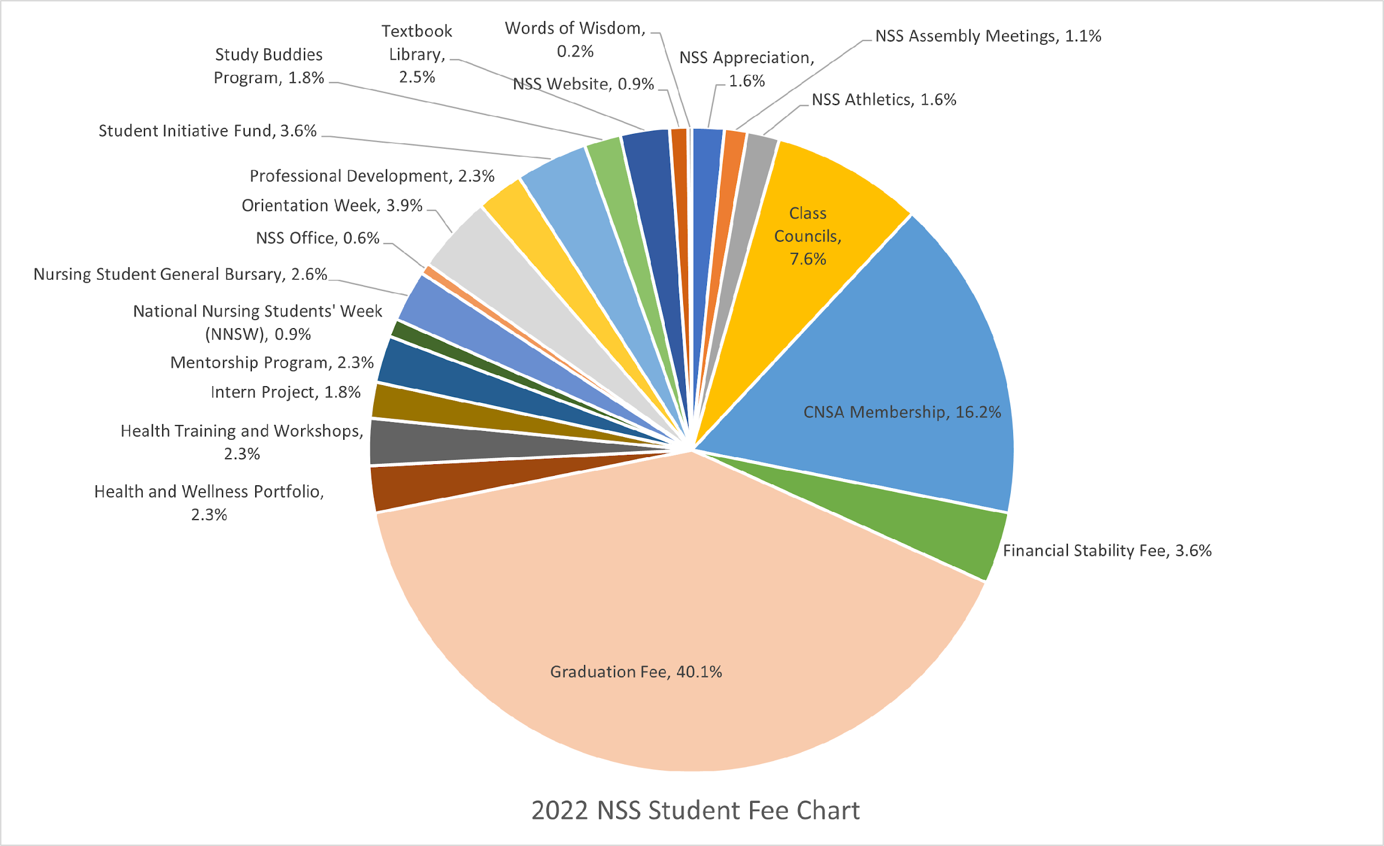
2022 NSS Student Fee Breakdown – Chart

There is a significant increase in surplus due to a high surplus arising from COVID-19 restrictions in the 2020 and 2021 budgets and discrepancies in 2020 budget calculations from 2019.
Does not reflect an exact 90% of student fees as $4400 was withheld from the NSS Graduation Fee in the Dec. 2021 deposit from an interim ORT invoice.
May not reflect an exact 10% of student fees as $4400 was withheld from the NSS Graduation Fee in the Dec. 2021 deposit from an interim ORT invoice.

