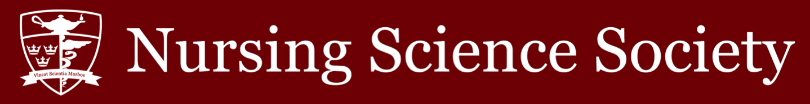

Date: September 14, 2022 Time: 1900

Minutes Taker (Position): Herbert Song (Vice President, Operations)
Purpose of Meeting: NSS Assembly Meeting

In Attendance:

✓ Crystal Sau (President)
✓ Dylan Rodgers (Vice President,
University Affairs)
✓ Herbert Song (Vice President, Operations)
✓ Ali Akbari (Senator)

☐ TBD (Presidential Intern)
☐ TBD (VPUA Intern)
☐ TBD (VPOPs Intern)
☐ TBD (NSS Assembly Speaker)

✓ Victoria Mihaylova (Academics & Professional Development Commissioner)
☐ TBD (Social Issues Commissioner)
☐ Victoria Okwudi (Health and Wellness Commissioner)
☐ TBD (Events Commissioner)
✓ Christina Pillkahn (Interprofessional
Commissioner)
☐ TBD (Director of Global Health)
☐ TBD (CNSA Official
Delegate)
☐ TBD (CNSA Associate Delegate)
☐ TBD (International Student
Representative)
☐ TBD (BIPOC Student
Advocate)
✓ Abbie Laurin (Head Cape)
☐ Brady Hurley (AST Head Cape)
☐ TBD (Class of 2026 President)
✓ Holly Burrows (Class of 2025 President)
✓ Sydney Pinto (Class of 2024 President)
☐ Liam Murdock (Class of 2023 President)
☐ TBD (AST Class of 2023 President)
☐ TBD (AST Class of 2024 President)

Meeting Minutes:

19:05 Meeting begins.

19:05 Motion 1, for the meeting of September 14, 2022, is passed.

19:07 Motion 2, approval of the meeting minutes of the March 30, 2022, meeting, is passed.

19:08 Guest speaker Dr. Erna Snelgrove-Clark begins her talk on commitments for the new year from the School of Nursing with regards to health and wellness, student well-being, and student voices.

19:54 President’s report. New AMS updates from the summer. Bus-It program reinstated. Student Experience Survey will have a new name and questions - to be released in 2023. Homecoming harm reduction strategies are being considered. Huge thank you to Head Capes for the successful execution of Orientation Week. Elections for Y1 and AST3 Class Councils open. Will be visiting a first-year class to promote elections. Some open positions available on the NSS. Trying to plan a meet-and-greet for late September and one in October, exploring catering options.

19:58 Vice President of Operations’ report. Planned events and completed paperwork in anticipation for the coming year. Plans listed in agenda. Please make sure to reach VPOPs at the correct email - vpops@nss.queensu.ca.

20:00 Vice President of University Affairs’ report. Interviews occurring this week for Commissioner positions. Many upper-year Class Council positions open, students encouraged to apply. Congratulations to Head Capes for a successful Orientation Week. Goals include transition of incoming VPUA and enhancement of graphic design skills

20:02 Senator’s report. No new updates.

20:02 Academics and Professional Development Commissioner’s report. Starting up Study Buddies program. Plans to collaborate with Crystal for the NSS mentorship program.

20:03 Interprofessional Commissioner’s report. Currently in a Facebook group chat, connecting with new interprofessional commissioners from other faculties.

20:04 Head Cape’s report. Orientation Week complete! Reach out with any questions or concerns.

20:04 Class of 2025 President’s report. Resubmitting calendar for the year. Started planning the scrub and stethoscopes sale for first-year students.

20:05 Class of 2024 President’s report. Currently brainstorming fundraising ideas for the year (e.g. merchandise sale).

20:05 Question period. No new business.

20:06 Discussion period. No new business.

20:06 Motion to adjourn the meeting of September 14, 2022, is passed

