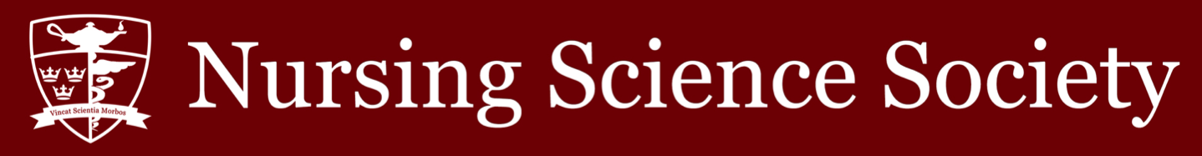

Date: September 8, 2021 Time: 7:00 pm

Minutes Taker (Position): Azra Jeraj (Vice President of Operations)
Purpose of Meeting: NSS Assembly Meeting

In Attendance:

✓ Nathaniel Gumapac (President)
✓ Emma Harris (Vice President,
University Affairs)
✓ Azra Jeraj (Vice President, Operations)
✓ Crystal Sau (Senator)
✓ Hikari Asaoka (Presidential Intern)
✓ Adelle Pagura (VPOPs, Intern)
✓ Anita Thevarajah (VPUAs, Intern)
☐ TBD (NSS Assembly Speaker)

✓ Herbert Song (Academic & Professional Development Commissioner)
☐ TBD (Social Issues Commissioner)
✓ Mila Jones (Health and Wellness Commissioner)
✓ Matthew Zhang (Events Commissioner)
✓ Katelyn Tigchelaar (Interprofessional
Commissioner)
✓ Jennifer Zhang (Director of Global Health)
☐ TBD (CNSA Official Delegate)
☐ TBD (CNSA Associate Delegate)
✓ Kerry Xu (International Student
Representative)
✓ TBD (BIPOC Student
Advocate)
☐ Carleigh Higgins (Head Cape)

✓ Julia Testani (Class of 2022 President)

✓ Nicole Gumapac (AST 2022 Class President)
☐ TBD (AST Class of 2023 President)
✓ Liam Murdock (Class of 2023 President)
✓ Dylan Rodgers (Class of 2024 President)
☐ TBD (Class of 2025 President)

Meeting Minutes

7:07 Meeting begins

7:08 Motion #1 to approve agenda for the meeting for September 8th is passed

7:10 President’s report, recap of summer AMS work, goals of communication and transparency for fall 2021, EDI initiatives, cultural humility

7:19 Vice President of Operations’ report. Orientation week funding for 4-year and AST track. Work on the website in making it more organized and easy to navigate. Goals include continuing to revitalize the website and ensuring that the budget is comprehensive by the end of term.

7:24 Vice President of University Affairs’ report. Updates from last semester (2023 Class Council, NSS contact list, NSS hiring. Increased engagement on @queensnss instagram page, working on summer highlights giveaway, midterm giveaways, AMS updates. Goals include increased engagement with the NSS, filling all NSS positions, creating a smooth transition for incoming executive team, prioritizing student success and wellness.

7:34 Senator’s report delivered by President. Meeting about Fall Break timeline.

7:36 Academics and professional development commissioner report. Reflected on the past year in planning tutoring sessions. Goals in creating a bundle for future academics commissioner.

7:39 Health and Wellness Commissioner’s report. Goals to keep up with social media, increase social media engagement and in student wellness group on FB. Hopes to collaborate with other commissioners on future events.
7:40 Events commissioner’s report. Goals to execute planned events and collaborate with commissioners.

7:41 Interprofessional commissioner’s report. Goal to execute card drive for ICU nurses.

7:42 International student commissioner’s report. Goal is to continue to establish a supportive network for international students.

7:44 Year 2 Class President’s report delivered by President. Proactive planning for stethoscope/scrub/BP cuff sales. Working on various fundraisers to raise money for the graduation fund.

7:45 Year 3 President’s report. Goal to increase fundraising.

7:50 Year 4 Class President’s report. Goals for this year.

7:54 AST Year 4 Class President’s report. Goals to support community and collaboration and maintain morale this upcoming year. Emphasizing the importance of mental health and connecting to resources.

7:57 Question period commences.

8:02 Discussion period commences. Guest speaker recommendations, NSS social media content brainstorming.

8:14 Motion to adjourn the meeting is passed. Seconded by Julia Testani.

